4.8, 4.9 TEST ms
1. (a) 2-amino(e) propanoic acid (1) 1
(b) (i) molecules with same structure / structural formula (1)
but with bonds (atoms or groups) arranged differently in space (3D) (1)
(ii) Plane polarised light (1)
Rotated (equally) in opposite directions (1) 4
(c) 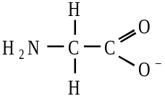 (1)
allow H2NCH2COO–
Penalise NH2- and OH- once per paper
but CH3– is allowed
1
(d) 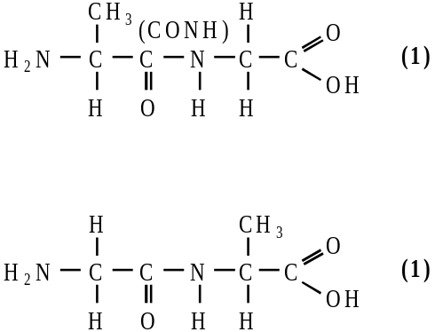
Not anhydrides; not repeating units
2
(e) 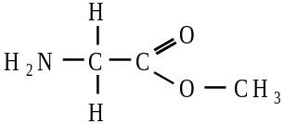 (1)
or H2NCH2COOCH3
1
[9]

2. (a) (i) CH3CH=CHCH3 1
Addition or radical (QoL) 1
(ii) CH3CH(OH)CH(OH)CH3 or with no brackets 1
butan(e)–2,3–diol or 2,3–butan(e)diol 1
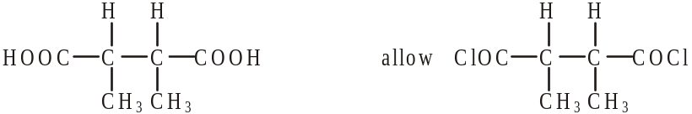
2,3–dimethylbutan(e)dioic acid 1
ignore –1,4–
condensation (QoL) 1
2,3–dimethylbutan(e)dioyl chloride 1

(iii) NaOH or HCl etc or Na2CO3 1
Allow conc sulphuric/nitric
NOT water nor acidified water nor weak acids
(b) Structure 1 1
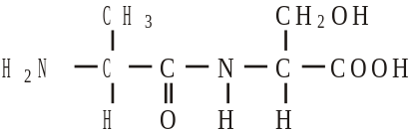
Allow –CONH– and –COHN–
Allow zwitterions
NOT polypeptides/repeating units
Structure 2 either of
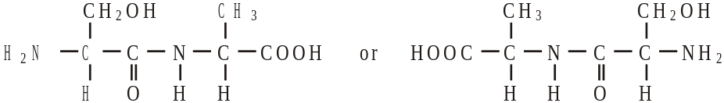
1
(c) (i) CH3CH2CH2Br 1
allow –Cl, –I
(ii) CH3CH2CN 1
(iii) (nucleophilic) substitution or from CH3CH2CH2Br 1
further substitution/reaction occurs or other products are formed 1
if reduction written here, no further marks
Allow reduction forms only one product
one of
(CH3CH2CH2)2NH
(CH3CH2CH2)3N
(CH3CH2CH2)4N+ Br– 1
Allow salts including NH4Br
Allow HBr
[15]
3. (a) polyamide or nylon (2,4) 1
(allow nylon without numbers but if numbers are present they must be correct)
condensation 1
(b) 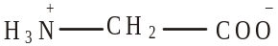 1
(c) ionic bonding in aminoethanoic acid 1
(can only score if includes that aminoethanoic is ionic)
stronger attractions than Hydrogen bonding in hydroxyethanoic
(e.g. stronger Hydrogen bonding in aminoethanoic acid scores 0) 1
(mention of electrostatic forces between molecules scores 0)
[5]

4. (a) (i) 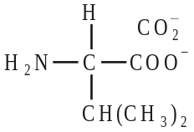 (1)
ignore Na+ unless covalently bonded
(ii) 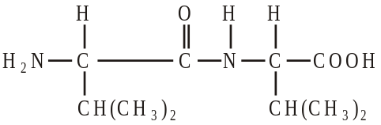 (1)
must be dipeptide, not polymer nor anhydride
allow –CONH– or –COHN–
allow zwitterion
(iii) hydrogen bonding (1) 3
QL
Allow with dipole-dipole or v derWaals, but not dipole-dipole etc alone
(b) (i) Type of polymerisation: addition(al) (1)
Repeating unit: 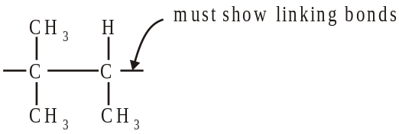 (1)
not multiples
allow n
(ii) CH3CH=CHCH2CH3 (1)
C2H5
(iii) 4
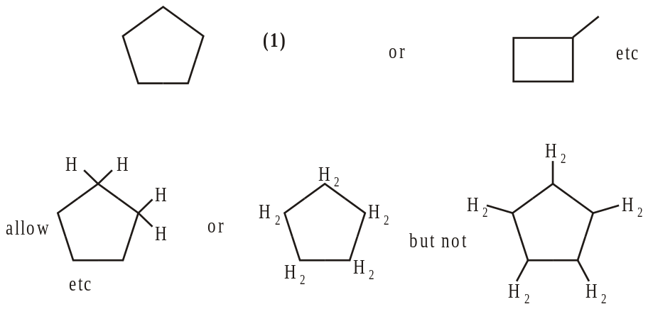
[7]

5. (a) 1, 4-diaminobutane or butane -1, 4-diamine (1)
A: BrCH2CH2Br or ClCH2CH2Cl (1)
B: NC CH2CH2CN
Step 1: Br2 or Cl2 (1) (ignore aq)
Step 2: KCN (1) (NOT HCN)
Step 3: H2 / Ni or LiAlH4 or Na / C2H5OH (1) (NOT NaBH4)
Hydrogenation only for H2 / Ni, or nucleophilic addition only for LiAlH4(1)
OR reduction or addition
7
(b) 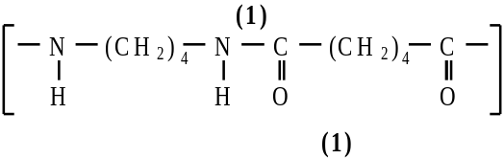
QL hydrogen bonding (1)
Polarity of H-bonding shown or discussed (1) 4
(c) Polyamides / peptide link can be hydrolysed (1)
OR polyalkenes cannot be hydrolysed
QL OH– attacks peptide link or Cδ+ (1)
poly(ethene) non-polar (1) 3
[14]

